Metallodrug Design: Bioinorganic Chemistry of the Rhenium(I)-tricarbonyl Fragment fac-[Re(CO)₃]⁺
Jakob Kljun
Faculty of Chemistry and Chemical Technology, University of Ljubljana, Večna pot 113, SI-1000 Ljubljana, Slovenia

Metal fragments have been an important structural feature in anticancer drug development over the past decades since the introduction of cisplatin into clinical practice in the late 1970s. Few other metal complexes have reached clinical trials and a common structural feature is the presence of multiple chelating ligands or chemically stable metal fragments that limit ligand substitutions generally to one ligand to increase the specificity of covalent binding to molecular targets (DNA or enzymes). In the past 20 years the most successful metallodrug development stories contain a compound with the general formula [M(Fcl)(Chel)(L)]^{n+} with pseudo-octahedral geometry in which the stability of the complex is achieved by a face-capping ligand Fcl occupying three coordination sites in facial geometry, a bidentate ligand Chel which modulates overall complex charge and redox properties of the metal M and a monodentate labile ligand (L) that undergoes hydrolysis to produce the active form of the molecule. Selected examples of this kind of structural fragments include the organoruthenium(II) [Ru(η⁶-p-cymene)]²⁺, organorhodium(III) [Rh(η⁵-Cp*)]²⁺ and most recently the rhenium(I)-tricarbonyl species fac-[Re(CO)₃]⁺. Our group focuses on the synthesis of bipyridine-like nitrogen chelators and their use in the design of bioactive metal complexes. Recently we have used these ligands in the design and speciation of compounds which include the organorhenium(I) fragment fac-[Re(CO)₃]⁺. Speciation studies have shown that this type of complexes is stable over a wide pH range and slowly release the halido ligand to form the respective aqua species which is deprotonated to form a mixed hydroxido complex above pH 7.4. Complexes show moderate toxicity towards a panel of human cancer cell lines as well as antiviral activity against the Herpes simplex virus 2.
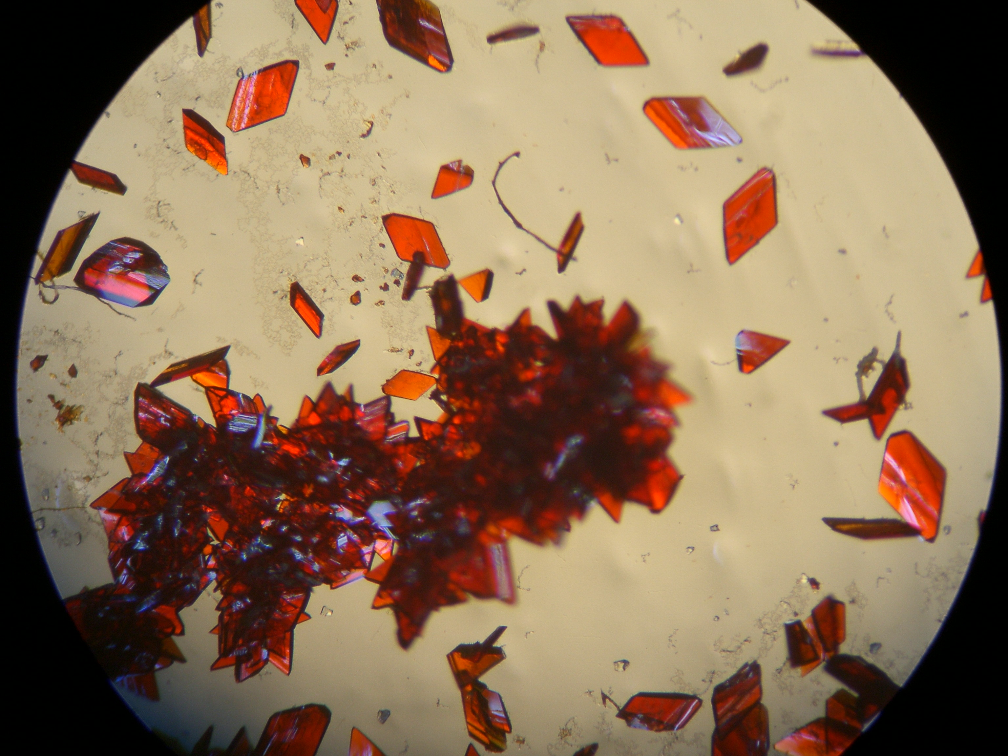
- T. Pivarcsik, J. Kljun, S. C. Rodriguez, D. Cortéz Alcaraz, U. Rapuš, M. Nové, E. F. Várkonyi, J. Nyári, A. Bogdanov, G. Spengler, I. Turel, É. A. Enyedy, Structural and solution speciation studies on fac-tricarbonylrhenium(I) complexes of 2,2′-bipyridine analogues. ACS Omega 2024, 9, 44601
- T. Pivarcsik, M. A. Kiss, U. Rapuš, J. Kljun, G. Spengler, É. Frank, I. Turel, É. A. Enyedy, Organometallic Ru(II), Rh(III) and Re(I) complexes of sterane-based bidentate ligands: synthesis, solution speciation, interaction with biomolecules and anticancer activity, Dalton Trans. 2024, 54, 4984-5000

