**The AUTHOR biographical sketch:**

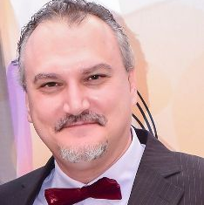

Mihai V. Putz is a laureate in physics. His numerous degrees include an MS in spectroscopy, PhD degree in chemistry with many postdoctorate stages: in chemistry (2002–2003) and in physics (2004, 2010, 2011), as well as an MBA in Management and a summa cum laude doctorate in management. He is full professor of theoretical and computational physical chemistry at West University of Timisoara, Romania, where he is Scientific Director of the Laboratory of Structural and Computational Physical-Chemistry for Nanosciences and QSAR. He is also affiliated with the Laboratory of Renewable Energies at the R&D National Institute for Electrochemistry and Condensed Matter, Timisoara, Romania. Dr. Putz is Editor-in-Chief of the International Journal of Quantitative Structure-Properties Relationships and New Frontiers in Chemistry. Prof. Putz is member of many professional societies and has received many national and international awards and accolades for his work, such as from the Romanian National Authority of Scientific Research, the German Academic Exchange Service DAAD, and the Center of International Cooperation of Free University Berlin. Along his career, he was declared the Best Researcher of Romania and recognized among the first Dr.-Habil. in Chemistry in Romania. Prof. Putz pursued his “second nature and passion” in Strategic Management and is making innovative contributions towards establishing quantum management new paradigm(s) as the forefront of the ex-post digital, artificial, and emotional Homo oeconomicus.